TITLE : “Clean Energy Transition and Carbon Emissions: A Time-Series and Regression Analysis for India”

Data Description
Data Source – Ember Power
Dataset Link - https://github.com/Nimish61/Renewable-Energy-Generation/blob/main/india_monthly_full_release_long_format%20(1).csv

Overview of the Dataset
This dataset contains electricity capacity and electricity generation data for India, published by Ember Power. It provides time-based information on how electricity is produced across Indian states and union territories, broken down by fuel types and clean vs fossil energy sources.
The data tells us:
  - How much electricity capacity does each state have?
  - What share of electricity comes from clean vs fossil fuels?
  - How has electricity generation changed over time?

Geographic Information Columns

Column | Description
Country | Name of the country (India)
Country code | ISO country code (IND)
State | Name of the Indian state or union territory
State code | Abbreviated code for the state (e.g., AN)
State type | Specifies whether the region is a State or Union Territory
Date | Date of observation (formatted as DD-MM-YYYY)

- Energy Classification Columns

Category |  | Subcategory
Value | Meaning | Value | Meaning
Capacity | Installed electricity generation  capacity | Aggregate fuel | Grouped fuel types
Electricity generation | Actual electricity generated | Fuel | Individual fuel sources
Power sector emission | CO2 emission caused by  generation

- Variable: This column specifies the energy source.

Variable | Meaning
Clean | All clean energy sources combined
Fossil | All fossil fuel sources combined
Renewables | Renewable energy sources
Wind and Solar | Combined wind + solar
Coal, Gas, Solar, Wind, Hydro | Individual fuel types

Measurement Columns

Unit | Meaning
MW | Megawatts (installed capacity)
% | Percentage share of total generation
GWh | Energy generated
ktCO2 | Kiloton CO2 emitted

Data Cleaning and Preparation

Initial Cleaning
  - Standardized all column names by stripping extra spaces and replacing spaces with underscores.
  - Converted the Date column to a proper datetime format, converting invalid dates to NaT.

Dataset Segmentation
The master dataset contains values for three different variable – (Capacity, Electricity generation, Power sector emissions).
Capacity – tells the maximum electricity which can be generated in the state per day. (Unit – MW) Electricity generation - tells the actual amount of energy generation in the state per day. (Unit – GWh) Power sector emissions – tells the CO2 emission due to the electricity generation. (Unit – KtCO2)
Hence, dataset was split into three subsets based on the Category column: Capacity, Electricity generation, Power sector emissions.

Cleaning Each Dataset
A reusable function handled the following steps:
- Classifying Values
  - Actual values (MW, GWh, ktCO₂) assigned to Actual_Value.
  - Percent values (containing "%") assigned to Percent_Value.
- Pivoting to Wide Format
  - Variables converted into individual columns using pivot tables.
  - Percent columns suffixed with "_Percent".
- Merging Outputs
  - Actual and percent pivot tables were merged into one wide-format dataset.

Exporting Cleaned Data
Cleaned outputs saved as:
- CLEAN_capacity.csv
- CLEAN_generation.csv
- CLEAN_emissions.csv

Feature Selection
The main features selected are:
Clean Generation – Energy Generated by Renewable Energy Sources. Fossil Generation – Energy Generated by Non-Renewable Energy Sources. Clean Emission – CO2 emission by Renewable Energy Sources.
Fossil Emission – CO2 emission by Non-Renewable Energy Sources.

Model Dataset Link - https://github.com/Nimish61/Renewable-Energy-Generation/blob/main/Renewable_model_data.

Modelling

Model 1: SARIMA for Renewable Energy
SARIMA stands for Seasonal Auto Regressive Integrated Moving Average. It is a time series forecasting model used when:
- Data depends on its past values
- Data shows a trend
- Data has seasonality (repeating patterns like monthly, quarterly, yearly)

Objective:
To model and forecast long-term trends in renewable energy generation by capturing seasonality and trend.

SARIMA Model Notation:
The SARIMA model is written as:
SARIMA(𝑝, 𝑑, 𝑞)(𝑃, 𝐷, 𝑄)_{𝑚}

Non-Seasonal Part
- p → Auto Regressive order (number of past values used)
- d → Differencing order (to remove trend)
- q → Moving Average order (number of past errors used)

Seasonal Part
- P → Seasonal Auto Regressive order
- D → Seasonal differencing order
- Q → Seasonal Moving Average order
- m → Length of the seasonal cycle

Prediction Plot:
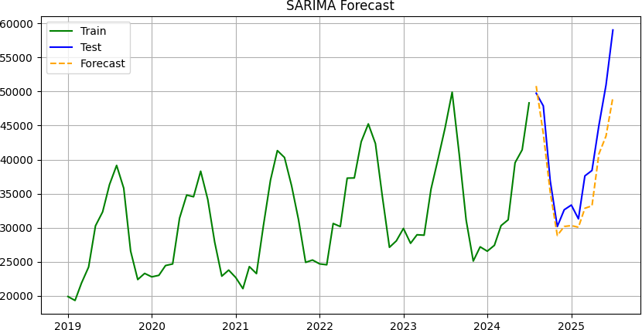
(Plot data link - https://github.com/Nimish61/Renewable-Energy-Generation/blob/main/Renewable%20Prediction.xlsx)
The plot illustrates the SARIMA model’s performance across training, testing, and future forecasting periods. The model captures the seasonal pattern well in the training data, shows reasonable alignment with the test data, and produces a forecast that continues the observed trend and seasonality.

Performance Metrics:

Mean Absolute Error (MAE) | 3852.326
Mean Square Error (MSE) | 21591797.845
Root Mean Square Error (RMSE) | 4646.698
Mean Absolute Percentage Error (MAPE) | 8.889

Interpretation:
The Mean Absolute Percentage Error (MAPE) of 8.89% indicates good forecasting accuracy, suggesting that the model effectively captures the short-term dynamics and seasonal structure of the time series. The Mean Absolute Error (MAE) value implies that, on average, the model’s forecasts deviate by approximately 3,852 units from the actual values. Furthermore, the relatively small difference between RMSE (4,646) and MAE indicates that the prediction errors are fairly stable over time, with no significant influence from extreme errors.

Forecast:
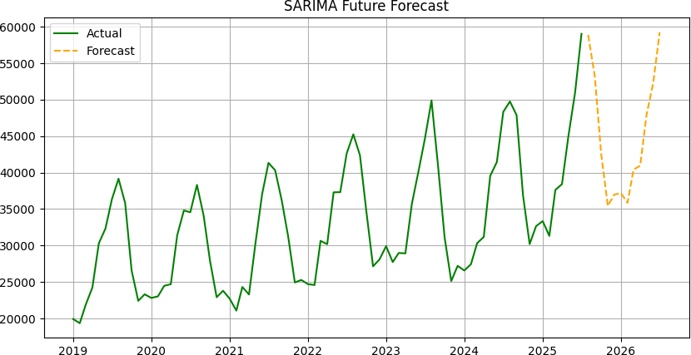
(Plot data link - https://github.com/Nimish61/Renewable-Energy-Generation/blob/main/Renewable%20Future%20Forecast.xlsx)
The plot shows the SARIMA model’s future forecast extending the historical trend and seasonal pattern of the data. The forecasted values maintain the recurring seasonal fluctuations while following the overall upward trend observed in the actual series.

Model 2: Holt-winter Exponential Smoothing for non-Renewable energy
Time series data that possess trend and seasonal components can be projected with the help of the Holt Winters method, which is also called triple exponential smoothing. This method requires three parameters for smoothing: alpha for the level, beta for the trend, and gamma for the seasonality component. The Holt-Winters method is applicable in real-time series forecasting problems because it is a robust method and is not affected by outliers in the series.

Objective:
To generate accurate 12-month-ahead forecasts of non-renewable (fossil-fuel-based) energy generation using the Holt–Winters multiplicative seasonal exponential smoothing model.

Model Equation:
The Holt–Winters exponential smoothing model applied for non-renewable energy has level and seasonal components. The model forecast equation for h-step ahead can be given as:
y(t+h) = l(t) ∗ s(t+h−mk)
where,
- 𝑦_{(𝑡+ℎ)}= forecasted non-renewable energy generation at time 𝑡 + ℎ
- 𝓁_{𝑡}= level component
- 𝑠_{𝑡}= seasonal component
- 𝑚 = 12= seasonal period
- h = forecast horizon
- k = (ℎ−1)
𝑚

Level update equation is:

α [ yt ] + (1 − α) ∗ l

s(t−m)
(t−1)

Seasonal update equation is:

y
t
Υ [ ] + (1 − Υ) ∗ s(t−m)
l
t
For this model the estimated parameter values are: α = 0.948, 𝛶 = 0.001 where,
- α = smoothing level parameter
- γ = smoothing seasonal parameter

Prediction Plot:
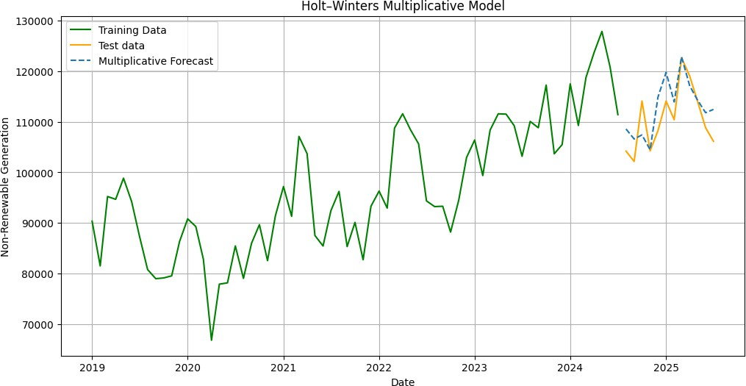
(Plot data link - https://github.com/Nimish61/Renewable-Energy-Generation/blob/main/Train_fossil.csv)

The green line represents the historical values of energy generated by non-renewable resources on which the model was fitted, the orange line is the actual values used of testing data and the blue dashed line represent the forecasts for the same test dates. The blue line closely follows the orange test line implies the model is capturing level, trend, and seasonality well and generalizing to unseen data.

Performance Metrics:

Mean Absolute Error (MAE) | 3601.65
Mean Square Error (MSE) | 18744674.058
Root Mean Square Error (RMSE) | 4329.51
Mean Absolute Percentage Error (MAPE) | 3.30%

Interpretation:
The Mean Absolute Percentage Error of 3.30%, indicates high forecasting accuracy and confirms that the model performs well in capturing the short-term dynamics and seasonal structure of non-renewable energy generation. The value of MAE implies that, on an average the forecasts produced by the model deviate by about 3,602 units from actual non-renewable energy generation. And the gap between RMSE and MAE is not much which indicates that errors are stable over time.

Forecast:
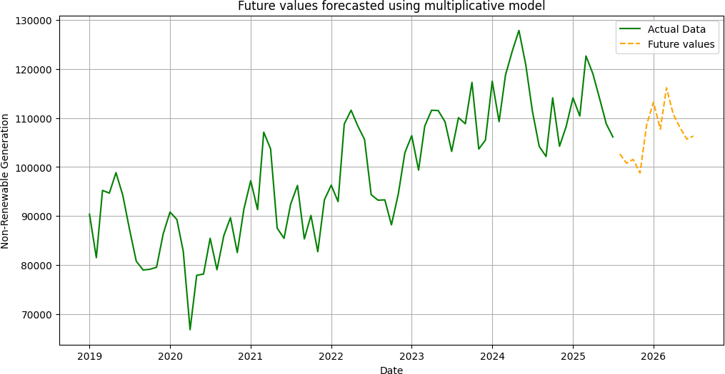
(Plot data link - https://github.com/Nimish61/Renewable-Energy-Generation/blob/main/Non_renewable.csv)

The green line represents the actual non-renewable generation values over time and the orange dashed line extending beyond the last observed date shows the model’s forecasted values for the next 12 months continuing the existing seasonal pattern in the future.

Conclusion from Forecasts -
- Fossil Generation Forecast
- Continues to increase
- Seasonal peaks exceed 115,000
- Indicates:
  - Rising electricity demand
  - Continued dependence on fossil fuels
Fossil energy is not being displaced, only supplemented.

- Clean Generation Forecast
- Strong upward trend
- Seasonal peaks reaching ~59,000
- Growth is faster in percentage terms than fossil
Clean capacity expansion is clearly happening.
- The share of renewable energy is increasing slowly and stabilizing, not declining.
Clean generation is growing.
Fossil generation is also growing.
Hence, absolute clean energy rises, but relative share rises only marginally.
- The forecasts indicate that while renewable energy generation is increasing substantially, fossil fuel–based generation continues to grow in parallel. As a result, the share of renewable energy in total electricity production shows only a modest increase. This growth pattern explains why clean energy significantly reduces emission intensity but does not lead to a statistically significant reduction in total emissions. Emission reduction targets cannot be achieved through renewable capacity addition alone; they require active displacement of fossil fuel generation or demand-side efficiency measures.
Hypothesis Testing

Objective :
To statistically check if use of Renewable energy source for energy generation reduces CO2 emission.

TEST 1 : Regression Test –

- Using Emission Intensity:
Emission Intensity is CO2 emission per unit total energy generated.

Emission Intensity = Total Emission
Clean Generation + Fossil Generation
Hypothesis :
Null Hypothesis - Clean generation has no effect on emission intensity.
H0​: βClean_generation ​= 0
Alternate Hypothesis – Clean generation has effect on emission intensity.
H1: βClean_generation != 0

We compare Clean Generation with Emission Intensity here.

OLS Regression Results
==============================================================================
Dep. Variable: Emission_intensity R-squared: 0.664
Model: OLS Adj. R-squared: 0.659
Method: Least Squares F-statistic: 151.9
Date: Mon, 22 Dec 2025 Prob (F-statistic): 6.71e-20
Time: 19:54:53 Log-Likelihood: 189.26
No. Observations: 79 AIC: -374.5
Df Residuals: 77 BIC: -369.8
Df Model: 1
Covariance Type: nonrobust
====================================================================================
coef std err t P>|t| [0.025 0.975]
------------------------------------------------------------------------------------
const 0.7377 0.010 73.222 0.000 0.718 0.758
Clean_generation -3.675e-06 2.98e-07 -12.325 0.000 -4.27e-06 -3.08e-06
=====================================================================================
Omnibus: 6.613 Durbin-Watson: 0.275
Prob(Omnibus): 0.037 Jarque-Bera (JB): 6.853
Skew: -0.702 Prob(JB): 0.0325
Kurtosis: 2.663 Cond. No. 1.36e+05

Conclusion :
At significance level α = 0.05:
- If p-value < 0.05 → Reject H₀
- If p-value ≥ 0.05 → Fail to reject H₀
Since p≈0.000<0.05
Reject the null hypothesis.
There is strong statistical evidence that:
- Clean generation has an effect
- The effect is negative
- Increasing clean generation reduces emission intensity
Also,
Coefficient is -3.675 x 10−6 which means –
If clean generation increases by 10,000 units:
$$10,000×3.675e-6=0.03675$$
Emission intensity drops by ~0.037, which is meaningful.

While clean generation does not significantly reduce total emissions after controlling for fossil generation, it has a strong and statistically significant negative effect on emission intensity, indicating improved environmental efficiency of the energy system. Clean energy lowers emissions per unit of electricity, but total emissions fall only when clean energy replaces fossil fuels.

- Using Clean Share:
Clean Share is share of Renewable sources in total energy generated.

Clean Share = Clean Generation
Clean Generation + Fossil Generation

Hypothesis :
Null Hypothesis - Clean share has no effect on total emissions.
H0​: βClean_share​ = 0
Alternate Hypothesis – Clean generation has effect on emission intensity.
H1: βClean_share​ != 0

OLS Regression Results
==============================================================================
Dep. Variable: Total_emission R-squared: 0.045
Model: OLS Adj. R-squared: 0.033
Method: Least Squares F-statistic: 3.669
Date: Mon, 22 Dec 2025 Prob (F-statistic): 0.0592
Time: 19:59:29 Log-Likelihood: -845.87
No. Observations: 79 AIC: 1696.
Df Residuals: 77 BIC: 1700.
Df Model: 1
Covariance Type: nonrobust
===============================================================================
coef std err t P>|t| [0.025 0.975]
-------------------------------------------------------------------------------
const 9.383e+04 6782.531 13.834 0.000 8.03e+04 1.07e+05
Clean_share -5.165e+04 2.7e+04 -1.915 0.059 -1.05e+05 2045.138
==============================================================================
Omnibus: 7.579 Durbin-Watson: 0.258
Prob(Omnibus): 0.023 Jarque-Bera (JB): 2.854
Skew: -0.003 Prob(JB): 0.240
Kurtosis: 2.069 Cond. No. 23.2

Conclusion:
- If p-value < 0.05 → Reject H₀
- If p-value ≥ 0.05 → Fail to reject H₀
Since, p=0.059>0.05
Fail to reject the null hypothesis at the 5% significance level.
Reject H₀ at the 10% level as p=0.059<0.10
So the result is marginally significant.
Also,
Coefficient is -51650 which means –
For a 10% increase in clean share:
$$-51,650×0.10=-5,165$$
Now compare that to typical emissions (~90,000):
Only ~5–6% reduction, which is not massive.

An increase in the share of clean energy is associated with lower total emissions but the effect is marginally significant and sensitive to temporal dependence. Clean energy share alone is not sufficient to significantly reduce total emissions unless overall energy demand is also addressed.

TEST 2 : Correlation Test :
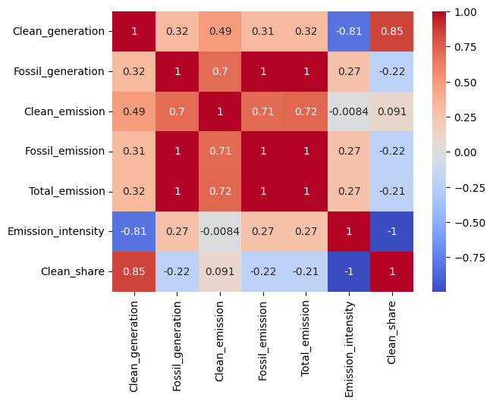
(Heatmap data link - https://github.com/Nimish61/Renewable-Energy-Generation/blob/main/Correlation.csv)

We can see that correlation between Clean_share (share of energy generated by renewable sources) and Total_emission is -0.21 which is low negative correlation showing increase in Clean_share leads to decrease in Total CO2 emission. Also Clean_generation (energy generated by renewable sources) and Emission_intensity ( CO2 emitted per unit total energy generated) is -0.81 which high negative correlation showing increase Clean_generation causes significant decrease in Emission_intensity.

Final Conclusion :

Both correlation and regression analyses consistently show that clean energy deployment significantly reduces emission intensity, indicating a cleaner and more efficient energy system. However, the effect of clean energy on total emissions is weak and statistically marginal, as total emissions are overwhelmingly driven by fossil fuel generation and overall energy demand.

India is greening its energy mix, but not fast enough to bend the absolute emissions curve.

Visualization of Generation and CO2 Emission -
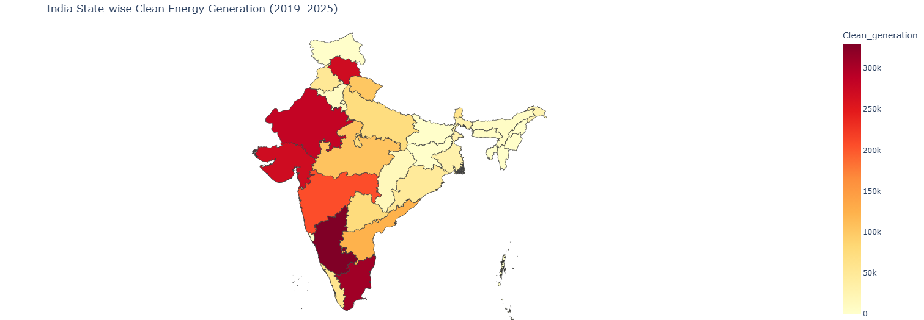
- State VS Total Renewable Energy generation (2019 – 2025 mid) –

What we see
- Renewable generation is more geographically dispersed than fossil energy.
- Strong clean energy performance appears in:
  - Southern and western states
  - Coastal and high wind regions
- Several high emission states still show low renewable penetration.

Why this happens
- High clean energy states benefit from:
  - Favorable solar and wind potential
  - Early renewable policy adoption
  - Large solar parks and wind corridors
- Low clean energy states often:
  - Remain locked into coal infrastructure
  - Face land, grid, or investment constraints

Key Insight
Renewable energy growth does not automatically occur in high emission states.
This highlights a structural transition gap between fossil dominance and clean adoption.

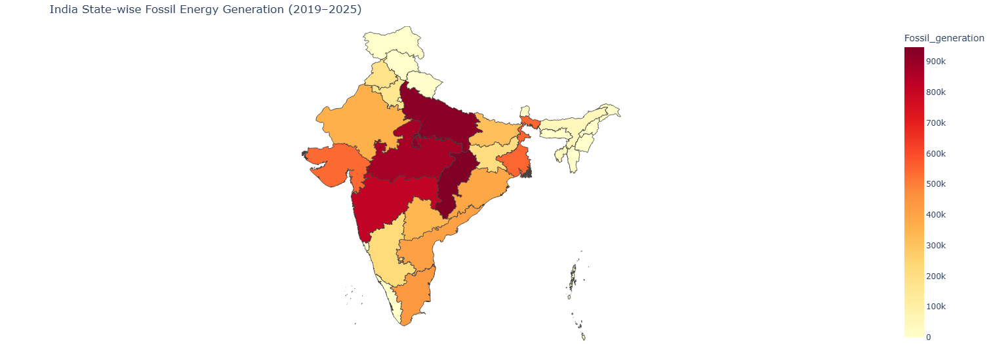
- State VS Total Fossil generation (2019 – 2025 mid) –

What we see
- Fossil energy generation is heavily concentrated in a few central and eastern states.
- The spatial pattern closely resembles the total emissions map.
- Southern and northeastern states generally show moderate to low fossil generation.

Why this happens
- Fossil dominant states often:
  - Sit near coal reserves
  - Host large legacy thermal power plants
  - Serve as electricity exporters to neighboring states
- States with lower fossil generation:
  - Lack coal resources
  - Have policy or geographic constraints
  - Rely more on renewables or imported power

Key Insight
Fossil energy generation is the single strongest spatial driver of emissions across India.
Where fossil generation is high, emissions are inevitably high.

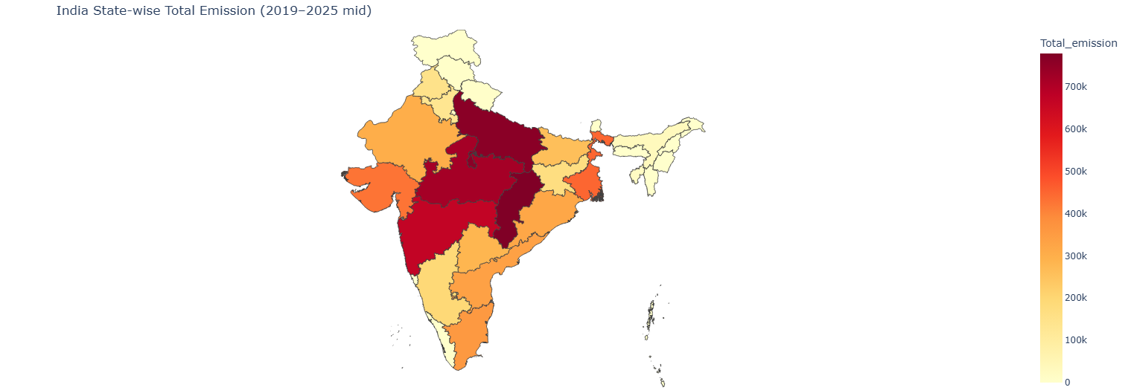
- State VS Total CO2 Emission (2019 – 2025 mid) –

What we see
- Central and north central states show very high total emissions.
- A contiguous emission belt is visible across coal and industry heavy regions.
- Northeastern states, Himalayan states, and island territories remain consistently low.

Why this happens
- High emission states typically have:
  - Large coal based thermal power plants
  - Energy intensive industries (steel, cement, mining)
  - High electricity demand from urban and industrial clusters
- Low emission states have:
  - Limited industrial activity
  - Lower power generation capacity
  - Higher dependence on imports rather than in state generation

Key Insight
Total emissions are driven primarily by fossil fuel power generation and industrial concentration, not by population size alone.
#Comments –
  - There are some issues either in the shape file or missing data for Andhra. If this is an old shape file please use the newest.
>> New shape file used. Changes can be seen above.

  - Mention the time in the plot title.
>> Title is mentioned in the plot.

  - Make a time series plot either region wise or state wise
